BOUNDARY VALUE PROBLEMS:
INTRODUCTION:
Classification of Partial Differential Equations of the Second Order:
The most general linear partial differential equation of second order can be written as,
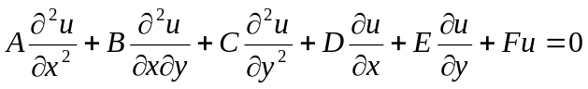
………(1)
where A,B,C,D,E,F are in general functions of x and y.
The above equation of second order(linear) (1) is said to
- Elliptic at a point (x,y) in the plane if B²-4AC < 0.
- Parabolic if B²-4AC = 0.
- Hyperbolic if B²-4AC > 0.
Examples:
Elliptic type: Parabolic type: Hyperbolic type:
1.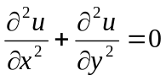 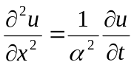 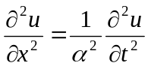
(Laplace Equation (one dimensional (one dimensional
In two dimension) heat equation) wave equation)
2.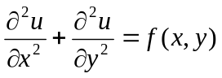
(Poisson’s Equation)

PROBLEMS:
1. Classify the following equation 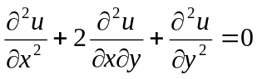
Sol:
Here A = 1, B = 2, C = 1
B²-4AC = 4-4 = 0 for all x, y.
Hence, the equation is parabolic at all points.

2. Classify the following equation x²f_{xx}+(1-y²)f_{yy} = 0.
Sol:
Here A = x², B = 0, C = 1-y²
B²-4AC = -4x²(1-y²)
= 4x²(y²-1)
For all x expect x = 0, x² is +ve.
If -1 < y < 1, y²-1 is negative.
B²-4AC is –ve if -1 < y < 1 , x ≠0
For -∞ < x < ∞ (x ≠ 0) , -1 < y < 1, the equation is elliptic.
For -∞ < x < ∞ (x ≠ 0) , y < -1 or y >1, the equation is hyperbolic.
For x = 0 for all y or for all x , y = ±1, the equation is parabolic.

